**Claim Reasons:** The Claim Reasons tab holds the list of eligible CNH claim reason codes, which are essential when filing a claim regarding a CNH part order.

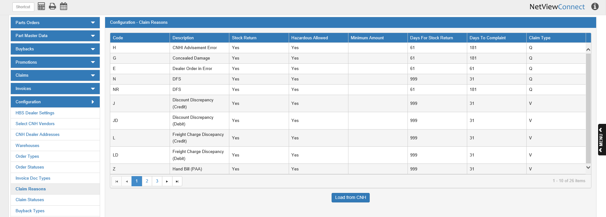

**Load from CNH:** When you first open the program, you will need to load the claim reason list from CNH, or you will not be able to access them when making claims. After the first use of this button, the list will automatically reload every 30 days, but you may click it at any time to receive the most updated version of the list.

**Column Definitions:**

Code: This column holds the CNH claim reason code.

Description: This column holds the claim reason represented by the code (order errors, charge discrepancies, etc.).

Stock Return: This column indicates whether or not a stock return is foreseen (Yes or No).

Hazardous Allowed: This column indicates whether or not a hazardous part return is foreseen (Yes or No).

Minimum Amount: This column shows the minimum amount required to create a claim. If the minimum amount is zero (0), there will be no entry in this column.

Days For Stock Return: This column shows the number of days the dealer has to return the goods.

Days To Complaint: This column shows the number of days the dealer has to make the complaint.

Claim Type: This column shows the claim type, which will be either:

* “Q” for Quantity
* “V” for Value